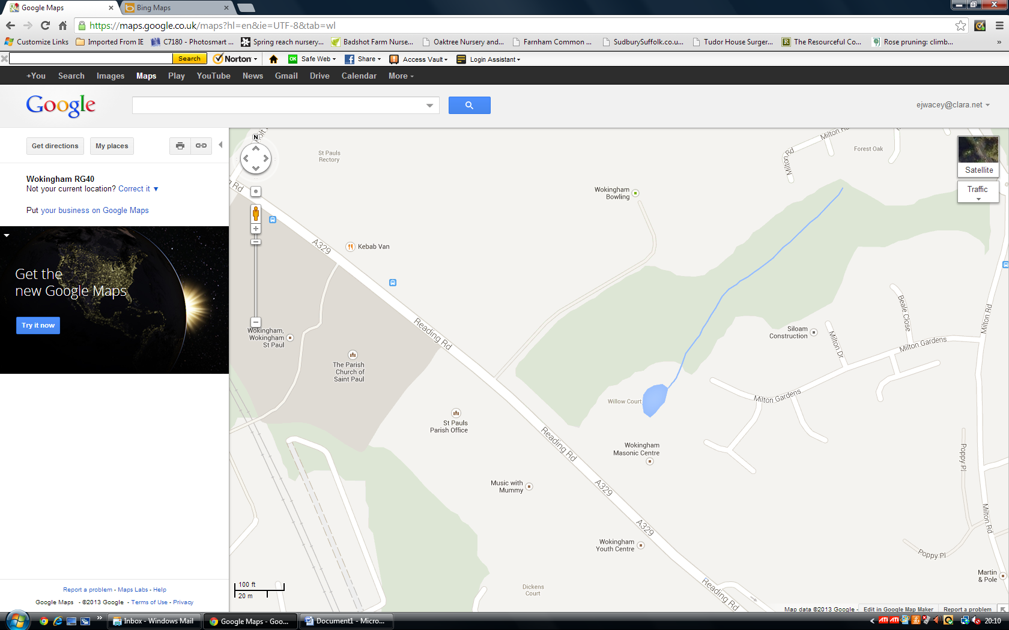

Masonic Centre Car Park Entrance

Wokingham Bowling Club Entrance